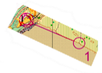
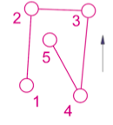
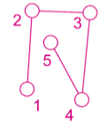
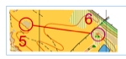
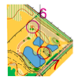
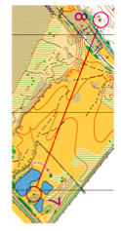
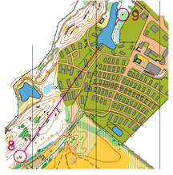
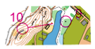
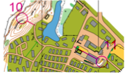
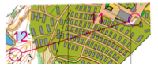
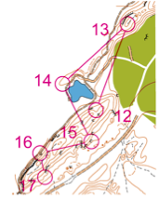
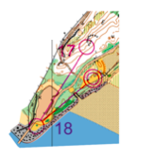
GREEN WITH A TWIST UNRAVELLED
Map memory S-1
Map memory 7-8
Map memory 5-6
Map memory 10-11
Map memory 8-9
Contour only 12-17
Map memory 9-10
Map memory 11-12
Map memory 17-F
Map memory 6-7
Compass only - no north line to really mess with the head!
North line would have been too easy

