Two Go to South Africa
  - John and Suse's O Tops (almost) go on safari
We knew when we were packed into the big suitcase that John and Suse were off on another jaunt and we hoped that it would be somewhere warmer than Kintyre. After a Boxing Day flight to London and then Johannesburg, all became clear. We were in South Africa for the Big 5 O.
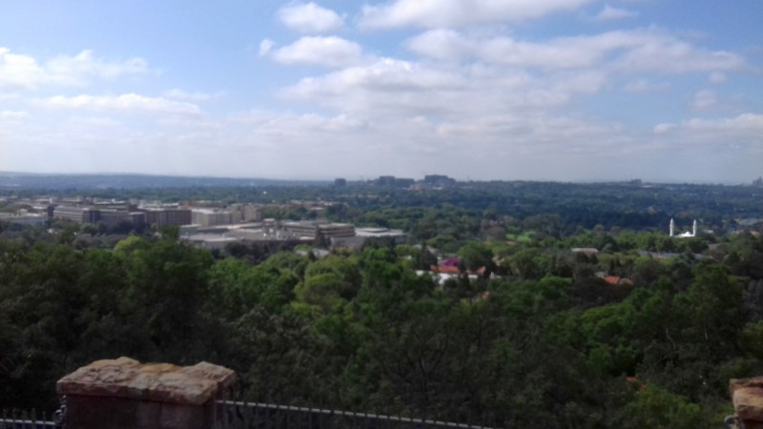
The time difference was just 2 hours which meant that recovery time was only needed to make up for lost sleep. We stayed in the hotel while John and Suse took a city sightseeing tour before picking up the hire car and driving north to Haertnesburg. Johannesburg was built on a ridge where gold had been discovered, then diamonds. It was surprisingly green and pleasant.
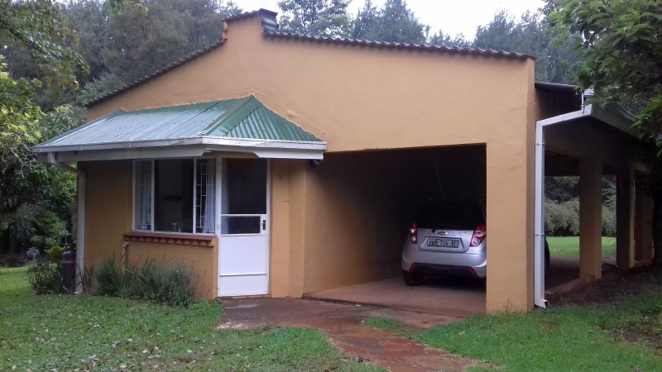
The scenery remained green as we first descended from the ridge then gradually began to climb again, the bleeps on the toll road marking our progress. There seemed little in the way of agriculture, just acres of what we supposed was 'bush'.
Registration was in Stanford Lake College, just a few miles from the 'farm' where we were staying. Access to the farm was via a dirt road and, as we were to discover, so was pretty well everything else.

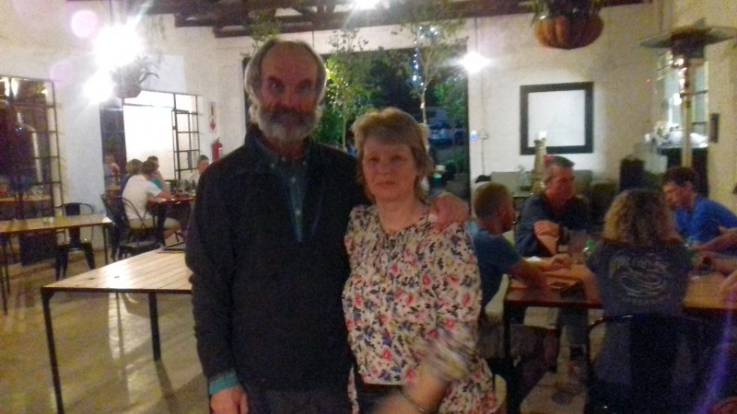
A welcome dinner was held that evening at a local restaurant, and we met up with most of the rest of the Scottish contingent. (This picture was taken by Dickie Jones, remember him?)

Day 1 was held on the Turfloop Nature Reserve back at Polokwane (pronounced Pollockwanny) where the University of Limpopo was sited. It was mainly flat terrain
with knolls, thickets and special trees making up a lot of the control descriptions. There were no tapes to the start triangle, so John had trouble finding it and as you can imagine, if you don't know where you're starting from..... 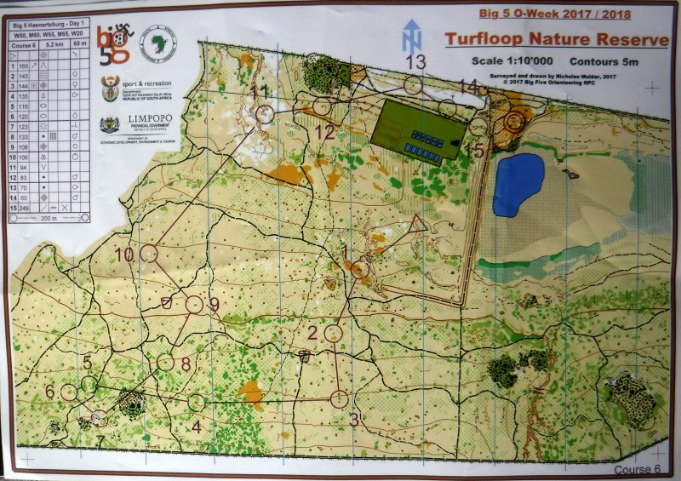
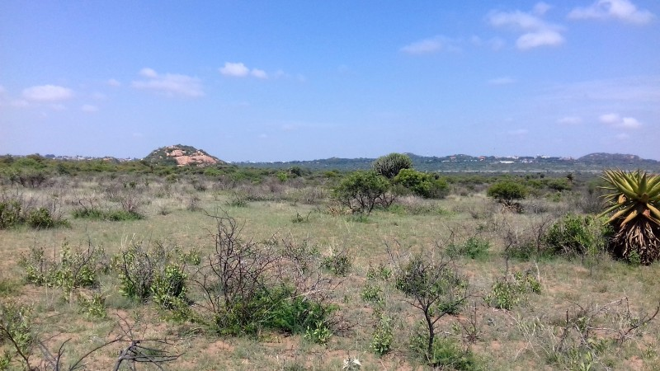
Suse was also struggling to interpret the complex gullies at the start and again near the end where a 100m leg took 25 minutes. Special trees were not all marked and it was a while before she realised that most of them were actually on the knolls, which was either helpful or not when trying to identify knolls.
It was hot going but very different from anything either John or Suse had experienced before. Perhaps because she was in wander mode, Suse noticed a herd of wildebeest and later 3 herds of giraffes. (She swears there are giraffes somewhere in this picture.)
That evening, there was a talk by mapper Dave Peel on the particular problems of oldskool mapping in South Africa. He had produced the map for the final sprint at the University. The new buildings had no straight walls and many of them had overhangs – do you map the edge of the building or the overhang? It sounded rather scary but interesting.
Days 2 and 3 were in The Wolksberg Mountains, up a very long and rutted dirt forestry road (I will never complain about Scottish potholes again!) Pine trees were the main crop and we saw monkeys playing at the side of the road. The mapped areas were typically Scottish with brashings and branches to negotiate as well as bracken and tall lily like shrubs. Despite the navigation being not particularly difficult, Suse still managed to do a 180 and slip off the map. Blame the heat!
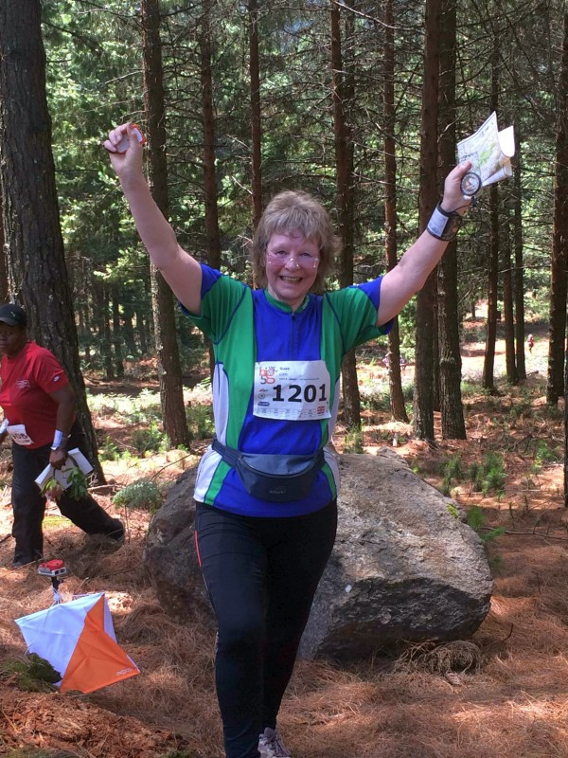
For many years in Scotland, John benefited from the combination of M40 and W21, which enabled him on occasion to team up with Lorna Boyd (now Eades). Yet again, M65 and W50 were paired, and Lorna's steady impeccable orienteering was extremely useful, resulting in a 2nd place for John on one day.
Suse's moment of glory came when, on 31st of December, she clocked up her 1000th mile of the year to complete the walk 1000 miles challenge. At around the same time, Colin Eades completed his personal challenge of running 10km every day.
Humungus storms saw out 2017. The thunder, lightning and golf ball sized hailstones quietened down later, leaving most of the region without power. In a country where the electricity supply company is manipulated by the government, folks are used to this and life went on with candles, generators and torches. We spent a nice evening warming up in front of the log burning stove while John and Suse went to the local pub.
The township proved to be a grid of squares with dwellings of some kind, ranging from a tin shed to a modern looking 1 or 2 storey house. Water supply came by a hose and there were portable toilets at a street junction. It's possible that people had pit toilets in their grounds as well.
Orienteering here had been sparked by a young man called Ephraim who had gone to college and discovered orienteering in Johannesburg. On returning to his village, he mapped the school grounds and made pin punches by bending over bits of wire and fastening them into old flip flops. It's amazing what they can do with old flip flops!
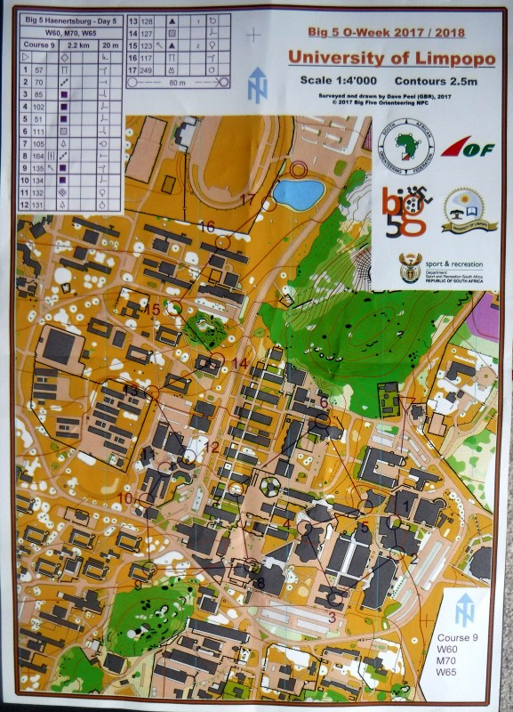
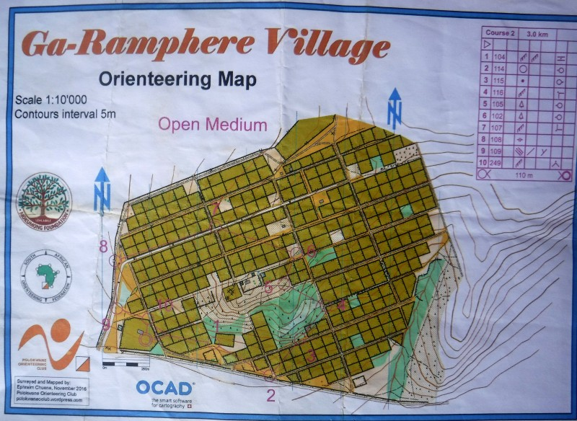
The event name corresponds not just to the fact that there are 5 days of orienteering but that most tourists come to South Africa to see the big 5 animals. Several of the Scots, either before or after, went to Kruger Park and/or the Drakensberg Mountains but John and Suse just had time to squeeze in couple of days in Cape Town before heading to Melbourne for school holiday babysitting duties.
They said that they would go back to another Big 5 in Africa. The mapping and planning were done to normal high standards and everyone was very friendly. It's also rather nice to get a dose of sunshine and vitamins at this time of year.
Yes, there is obviously extreme deprivation, but the climb out of the apartheid days is definitely happening and well worth patronising and the rand is even weaker than sterling!
And wouldn't you know it, there was a park race in Cape Town which I rather enjoyed before being packed (without being washed) into the suitcase again!
