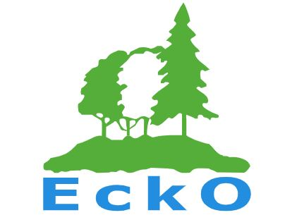
ORDER FORM FOR NEW CLUB TOPS (2024)

Please complete the information below if you wish to order a new EckO club o-top, jacket or hoodie.
The full Bryzos Size Guide can be found at https://www.bryzosport.com/size-guide or see end of order form for the downloaded version
Style | Size | Number | Price/Item | Total
Short Sleeve O-top – Adult (unisex) |  |  | £30
Short Sleeve O-top – Junior (unisex) – Size 110 - 150 |  |  | £25
Mesh top – Adult (unisex) |  |  | £25
Mesh top – Junior (unisex) |  |  | £20
Silva Jacket – Adult (unisex) |  |  | £50
Silva Jacket – Junior (unisex) – Size 110 - 150 |  |  | £40
Hoodie (Royal Blue) |  |  | £32
 |  |  | Total Price | £

NOTE: The Short and Long Sleeve O-Tops and Jackets have a small rear zip pocket. Hoodie price includes EckO logo on left chest and back. Price per item includes 20% VAT on adult items and delivery charge. Note:

FURTHER DETAILS
Name
Address
Email
Telephone

For further information on clothing, you can visit www.bryosport.com. Please send completed order form, but NO money to Liz Cottier cardingmill@gmail.com BY SUNDAY 26th May 2024

O-top, Jacket and Hoodie Design
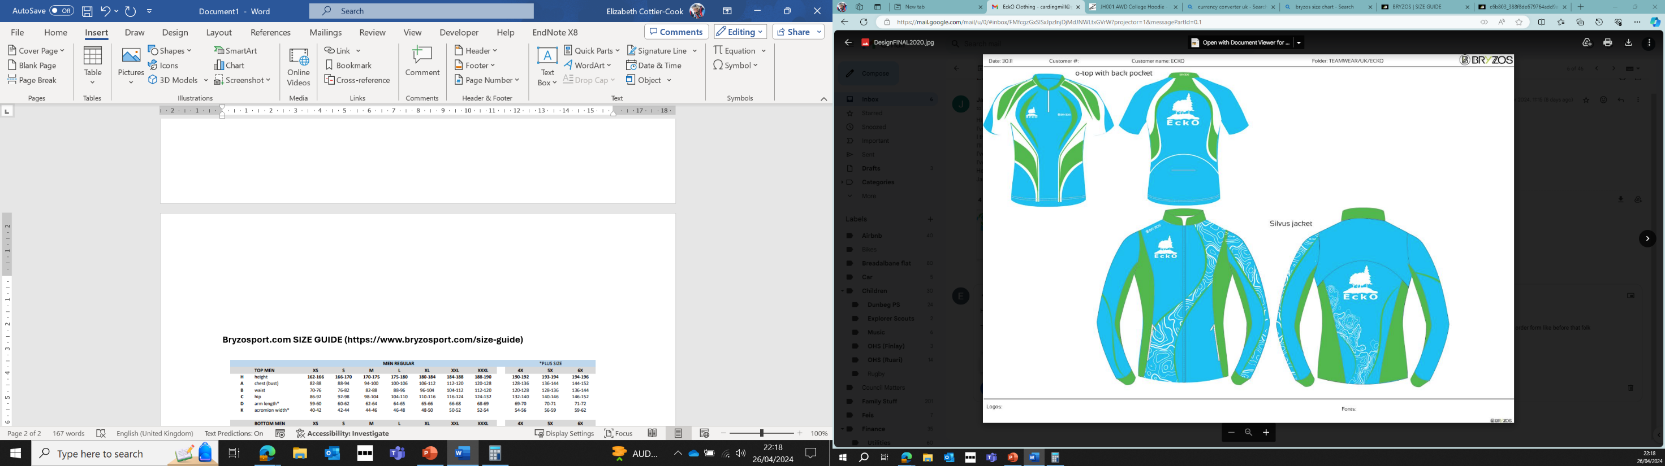

Zippy Embroidery – Chest Sizes for Hoodies
XS - 34", S - 36", M - 40", L - 44", XL - 48", 2XL - 52", 3XL - 56", 4XL - 60", 5XL - 62"
Bryzosport.com SIZE GUIDE for O-tops and O-jackets (https://www.bryzosport.com/size-guide)
